The Oaks Federation

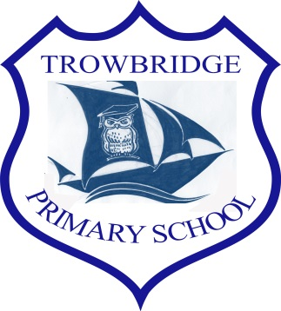
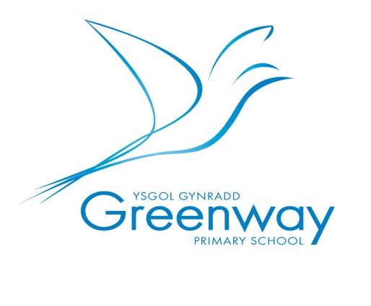

Handwriting Policy

Handwriting policy
We aim for our children to leave in Year 6 with the ability to write using their own style of fast, fluent and legible handwriting, as well as other styles of writing for specific purposes. In addition to teaching handwriting during our regular handwriting lessons, we have high expectations that what is taught and practised in handwriting lessons will be used in all writing activities. We believe that handwriting is integral to a child’s personal development and know that children’s engagement and self-esteem can be improved by their satisfaction and pride in good quality presentation.

Aims
Handwriting is a taught skill that develops at different rates for different children. All of the teachers in the school prioritise the teaching of handwriting and have high expectations for handwriting across the curriculum. Our school uses Penpals for Handwriting to support our systematic and progressive approach:
- The importance of handwriting is recognised and given appropriate time.
- The progression of handwriting is consistent across the school.
- Handwriting is acknowledged to be a whole-body activity and emphasis is placed on correct posture and pencil grip for handwriting
- Expectations of left-handed children are equal to those of right-handed children, and appropriate advice and resources are available to ensure that they learn to write with a comfortable, straight wrist.
- Handwriting is linked to grammar, punctuation and spelling in order to practise and contextualise all of the transcriptional and stylistic skills for writing.
- Children learn to self-assess their own writing and develop understanding and
responsibility for improving it.
- Children learn to write in different styles for different purposes such as print for labelling a diagram, illustrated capitals letters for creating a poster, swift jottings for writing notes, making a ‘best copy’ for presentation and fast, fluent and legible writing across the curriculum.

Progression of skills
In order to secure progression in the development of handwriting, teachers use:

The Penpals sequence of learning for Foundation-Year 6

- First, children experience the foundation of handwriting through multi-sensory activities across Nursery and Reception which is closely linked to phonics development
  - Correct letter formation is taught, practised and consolidated within phonics sessions
  - Joining is introduced only after correct letter formation is used automatically.
  - Joins are introduced systematically and cumulatively (Y2–Y6).
  - As children practise joining, they pay attention to the size, proportion and spacing of their letters and words (Y3–Y6).
  - Once the joins are secure, a slope can be introduced in order to support increased speed and fluency (Y5).
  - Children are introduced to different ways of joining in order that they can develop their own preferred personal style (Y6).

We share the aspirations that children’s handwriting should be sufficiently fluent and effortless for them to manage the general demands of the curriculum and that problems with forming letters do not get in the way of their writing down what they want to say.

Handwriting Lessons
The teaching of handwriting is organised according to age-appropriate teaching methods.

Nursery and Reception:
Children have access to mark-making tools as part of their daily continuous provision and have a wide range of opportunities to develop fine and gross motor skills.
Teachers provide opportunities and support children in developing motor skills in preparation for writing during:
  - Child-initiated activities, adult-led tasks and continuous provision
  - Adult-led motor skills activities
  - Daily Phonics activities
  - Daily Phonics lessons
  - Writing sessions, both adult-led and child-initiated

Years 1 to 6:
Teachers will follow the termly ‘Scope and Sequence’ sessions within this policy during:

- 1 handwriting session per week lasting 15 minutes (approx.)
- All work to be completed at the rear of the lined literacy books
- Space between lines will decrease progressively throughout the school
- Sessions will be delivered in smaller groups for Year1 and Year 2
- Year 3-6 will have whole class focus sessions

Assessment of skills

Handwriting at The Oaks Federation is assessed through writing moderation conducted by class teachers with school leaders.

Handwriting tools
Throughout their time in school, children use a range of tools for different purposes and styles of handwriting including:
- A wide range of tools and media for mark-making in the Early Years.
- Whiteboard pens throughout the school.
- Art supplies including coloured pens and pencils for posters, displays and artwork.
- Agreed school handwriting pens for writing from years 3-6 or when the pupil is ready to move from pencil to pen (teacher discretion)
- Additional handwriting resources are available in a central area for supporting specific needs in and out of school

Assessment of skills
Handwriting at The Oaks Federation is assessed through writing moderation conducted by class teachers with school leaders during staff meetings.

Equality of opportunity
All children have equal access to handwriting lessons and to the resources available. We recognise that some children take longer to develop the necessary skills and we cater for those children by providing additional opportunities for skills development. Children who need specific fine motor or handwriting interventions are identified early and the impact of interventions is carefully monitored. Children with a physical disability are catered for, and progress is monitored, according to their individual development plans.
The 7 Point Check
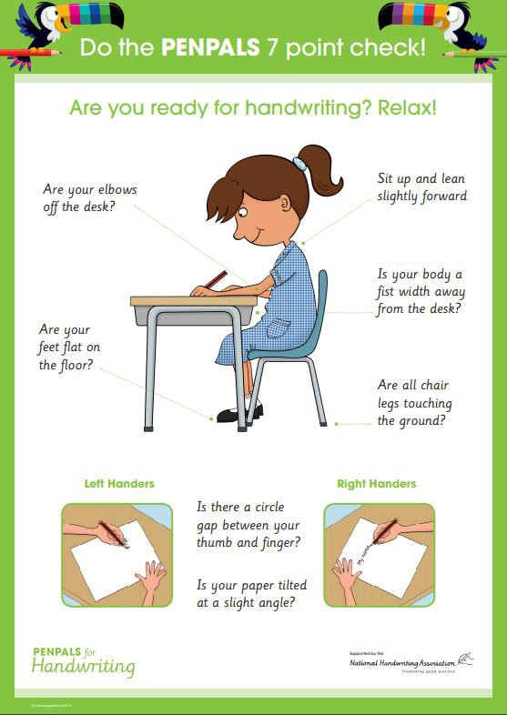

Development Levels of Pencil hold
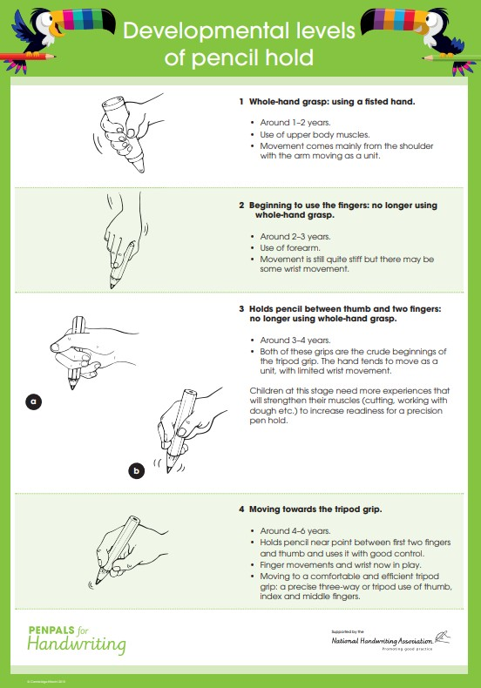

=
Upper and Lower case alphabet formation

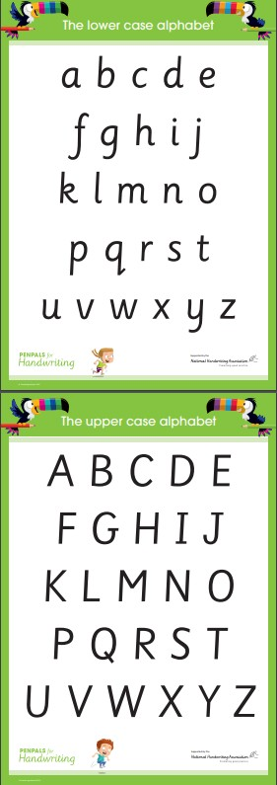

Letters that start with a similar pen movement are taught as a family in order to develop fluency.
Letter Families for Handwriting
Letters that start with an anti-clockwise curve:

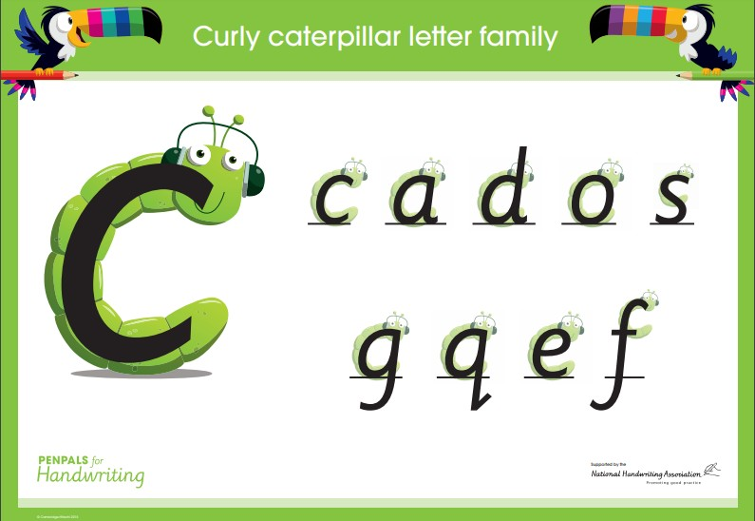

Letters that start with a downward stroke and curve round:
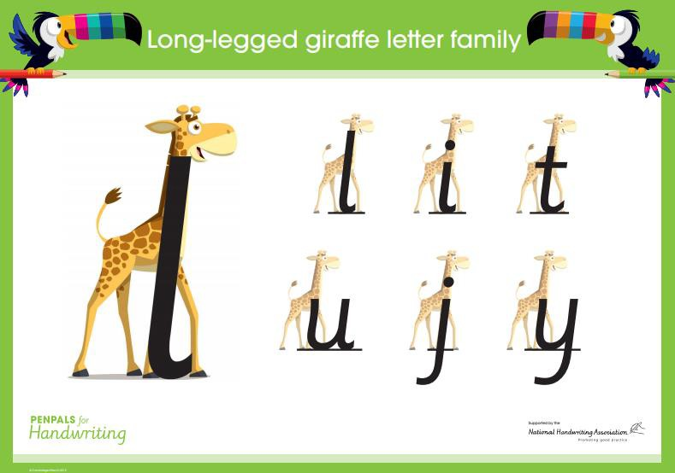

Letters that start with a downward stroke followed by an upward stroke:
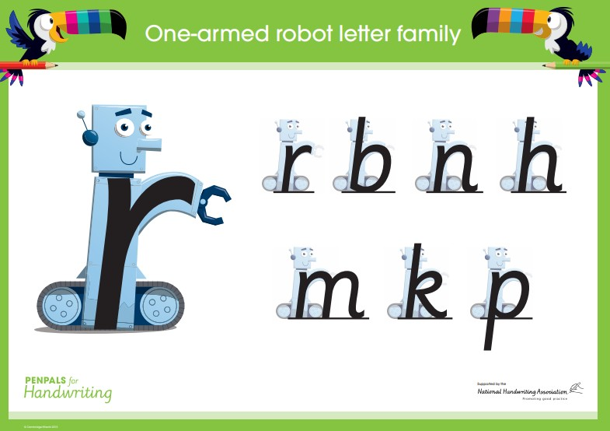
Letters with an angular ‘zig-zag’ formation:
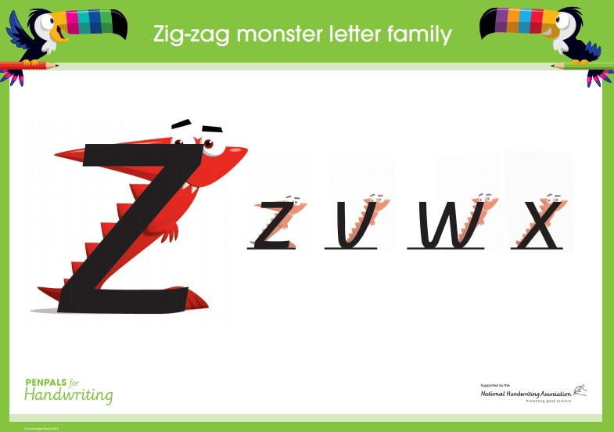
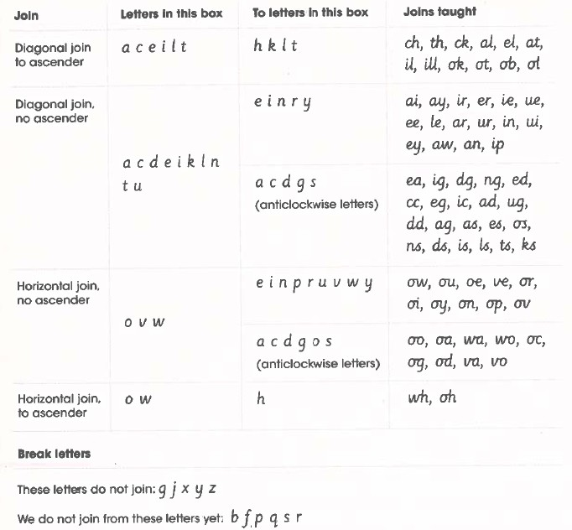

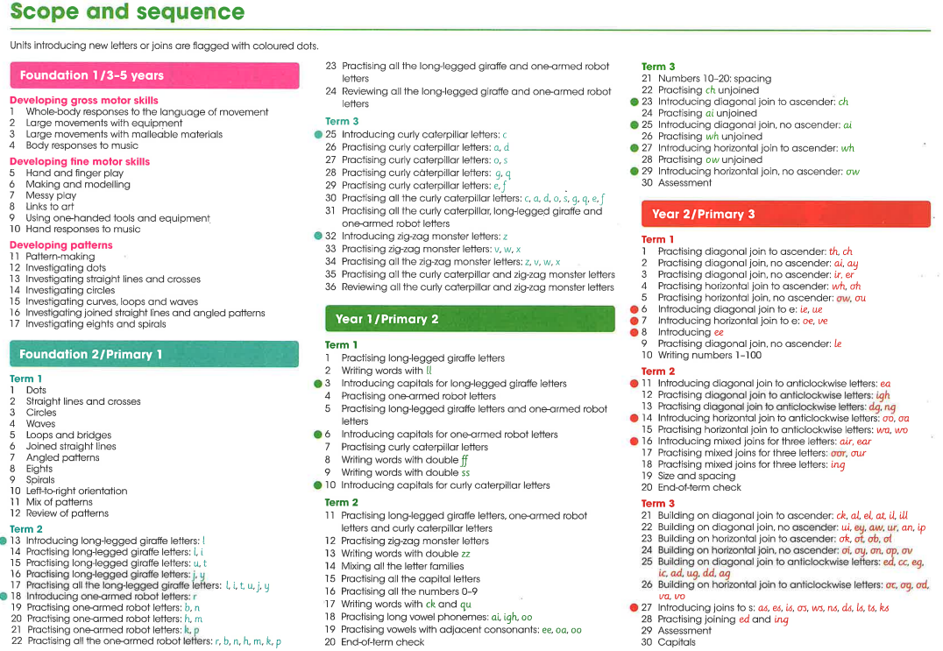
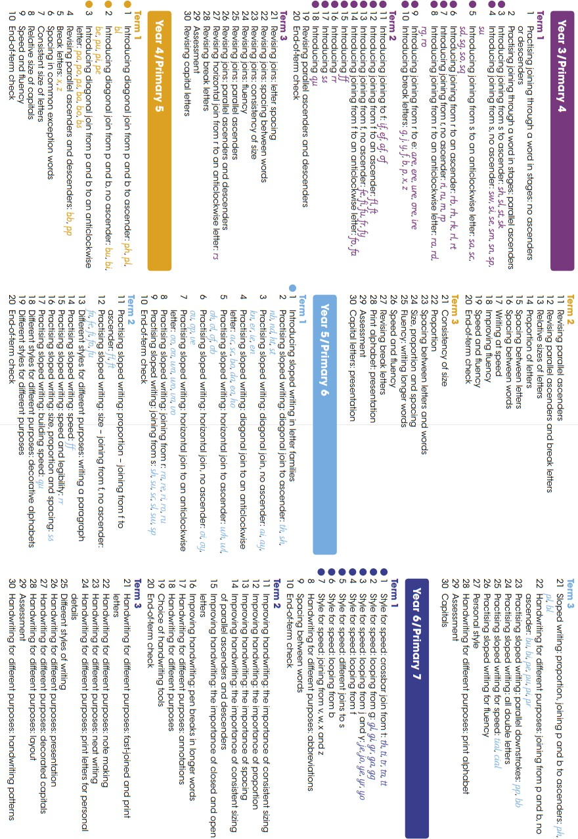
Letter Formation Mnemonics
Teachers and children can say these mnemonics from the Read Write Inc. phonics scheme as they write the letters to aid fluent and accurate formation:


