The Oaks Federation
Y Sylfaen Derw

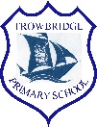
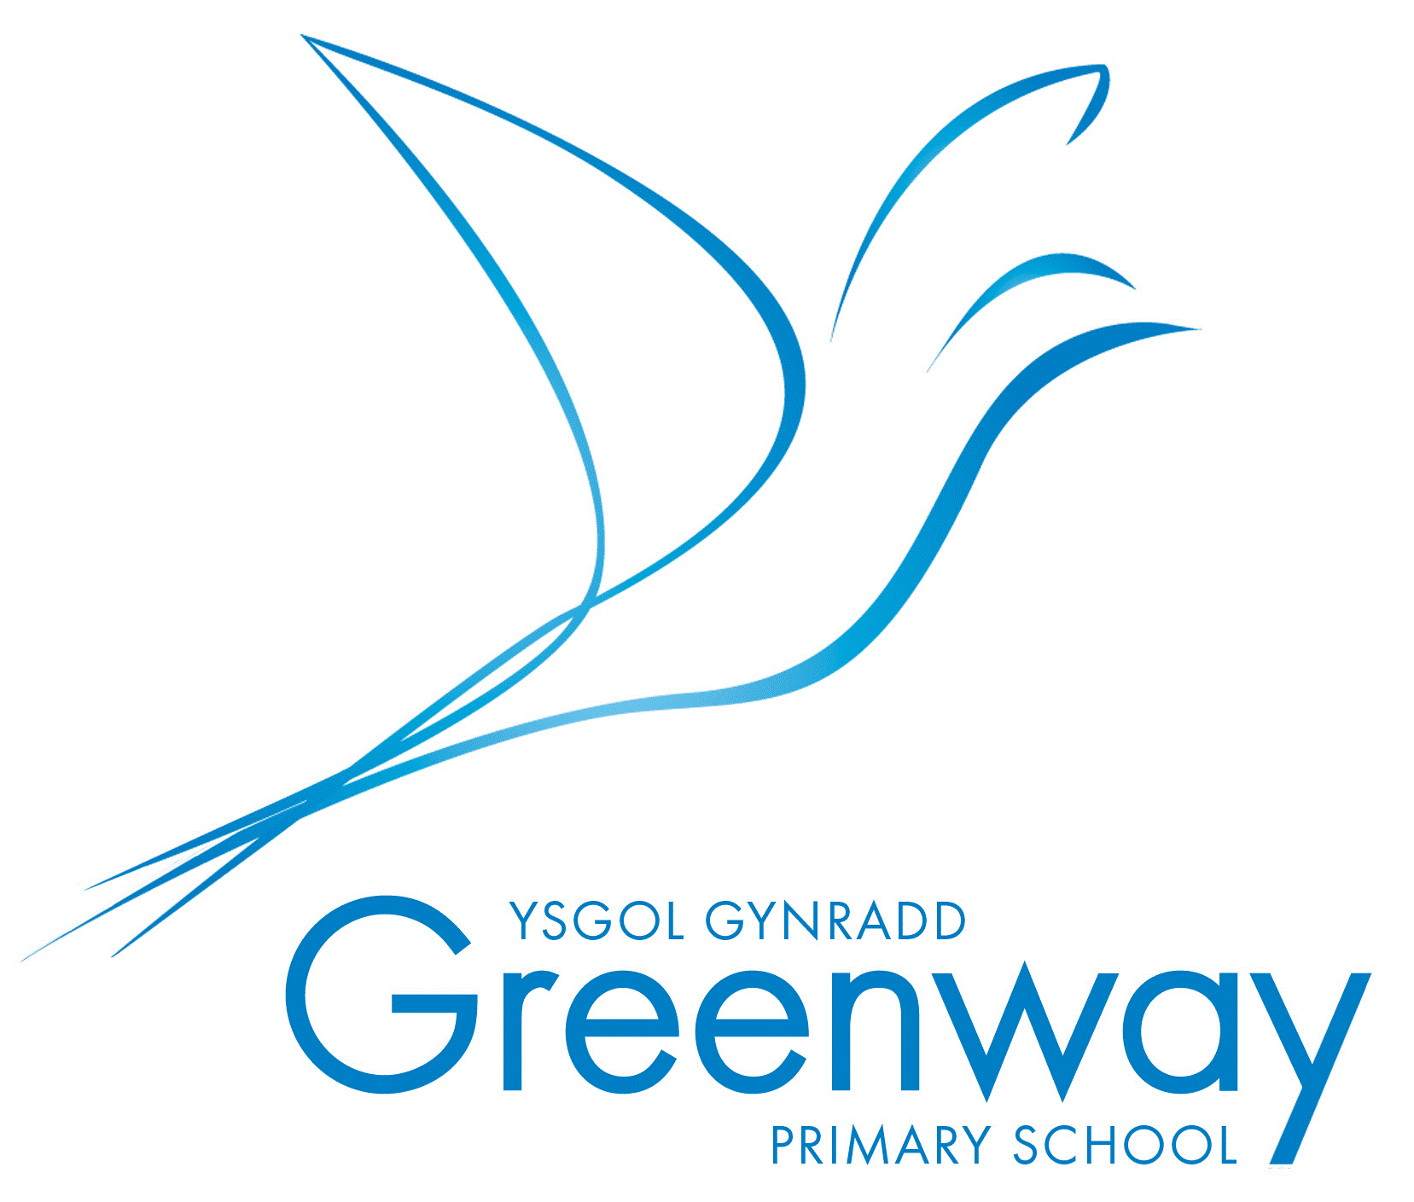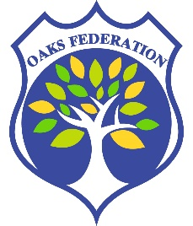
Achieving Excellence Together Dream. Explore. Discover.

Sichrau Rhagoriaeth Gyda’n Gilydd Breuddwydiwch. Archwiliwch. Darganfyddwch.

Our curriculum has been co-constructed through engaging with all stakeholders and will meet the following requirements:

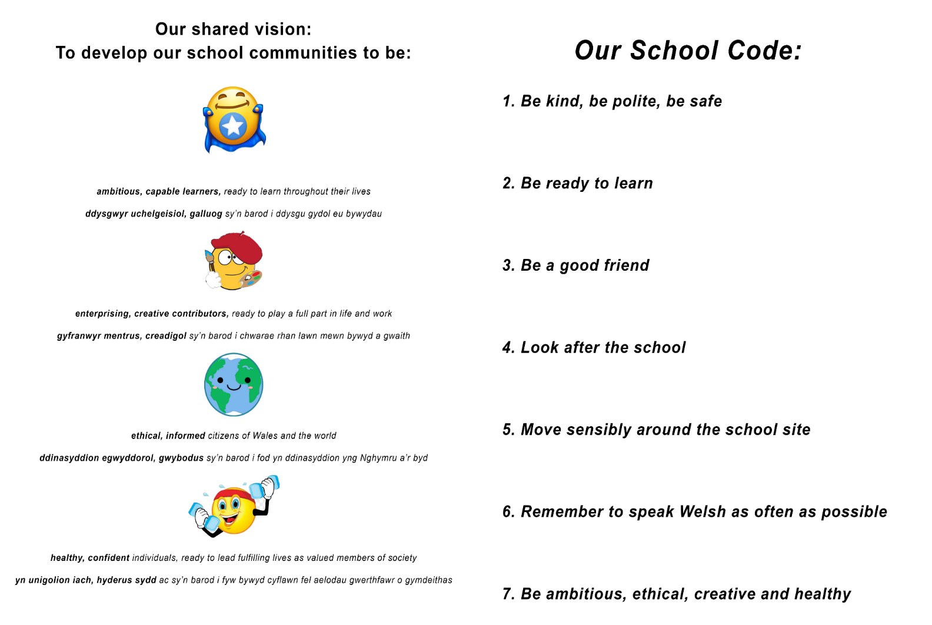
Our Inclusive Curriculum

Our curriculum will raise the aspirations for all learners. As a school we have considered how all learners will be supported to realise the ambitions and aspirations of the four purposes, and to progress. We have considered our ALN provision and how we will meet the needs of different groups of learners.

The Four Purposes

The four purposes are the starting point and aspiration for our school curriculum design. Our school aims to support all learners to become:
- ambitious, capable learners, ready to learn throughout their lives
- enterprising, creative contributors, ready to play a full part in life and work

- ethical, informed citizens of Wales and the world

- healthy, confident individuals, ready to lead fulfilling lives as valued members of society

The Statements of What Matters

Our curriculum will provide rich opportunities and authentic learning experiences to develop the key concepts, knowledge and skills as described in the statements of what matters and in line with the Statements of What Matters Code

Areas of Learning and Experience
Our curriculum will provide learning experiences through the 6 AoLEs of:
- Languages, Literacy and Communication

- Expressive Arts

- Science and Technology

- Humanities
- Maths and Numeracy

- Health and Wellbeing

Learning, Progression and Assessment

Our curriculum will support learning through designing learning opportunities that draw upon the pedagogical principles.

Our curriculum, supported by effective learning and teaching enables learners to make meaningful progress. Over time our learners will develop and improve their skills and knowledge. Our curriculum focuses on understanding what it means to make progress in a given Area or discipline and how learners should deepen and broaden their knowledge and understanding, skills and capacities, and attributes and dispositions and is informed by the https://gov.wales/curriculum-wales-progression-code . This in turn supports our approach to assessment, the purpose of which is to inform planning for future learning. Assessment will be embedded as an intrinsic part of learning and teaching. All learners will be assessed on entry to the school.

Welsh and English

As an English medium school learning will take place in Welsh and English from the early years onwards.

Cross curricular skills

Our curriculum will develop the mandatory cross-curricular skills of literacy, numeracy and digital competence. Our curriculum will enable learners to develop competence and capability in these skills and to extend and apply them across all Areas. Learners will be given opportunities across the curriculum to:
- develop listening, reading, speaking and writing skills
- be able to use numbers and solve problems in real-life situations

- be confident users of a range of technologies to help them function and communicate effectively and make sense of the world

UNCRC / UNCPRD

Our school will promote knowledge and understanding of Part 1 of the UNCRC, and of the UNCRPD, among those who provide learning and teaching.

CWRE

Our curriculum will incorporate careers and work-related experiences for all of our learners.

RSE

Our school curriculum embraces the RSE guidance and mandatory RSE Code. Our RSE provision will have a positive and empowering role in our learners’ education and will play a vital role in supporting them to realise the four purposes as part of a whole-school approach. Helping learners to form and maintain a range of relationships, all based on mutual trust and respect, is the foundation of RSE. These relationships are critical to the development of emotional well-being, resilience and empathy.

RVE

Religion, values and ethics (RVE) is a statutory requirement of the Curriculum for Wales and is mandatory for all learners from ages 3 to 16.

There is no parental right to request that a child is withdrawn from RVE in the Curriculum for Wales

As RVE is a locally determined subject, the agreed syllabus specifies what should be taught in RVE within the local authority and our curriculum will reflect this guidance.

Review and refinement

Our school curriculum will be kept under review in order to respond to the outputs of professional inquiry, the changing needs of learners and social contexts and needs. This will ensure our curriculum is both inclusive and responsive, meeting the needs of all learners. The reviews will take into account the views of stakeholders and will be signed off by the Governing Body. We will publish a summary of our curriculum and revise the summary if changes to the curriculum are made during the review process.

Headteacher : N. Naish | 11.07.2024

Chair of Governors: B Jeffries | Ysgol
Review date: July 2025 | “Providing each individual with the wings to

