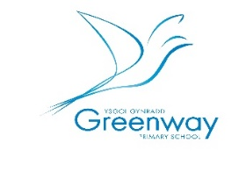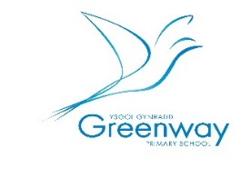Greenway Primary School

Year 2/Blwyddyn Dau

Welcome back! Here is some useful information to help you settle into your new class.

* Context *Cyd Destun* 
* Spring- Planes, Trains and Automobiles

We will be learning about different modes of transport. This will include learning about transport in the past and present and how they might change in the future. We will also be looking at key historical people who were part of inventing and developing these modes of transport.

PE *Ymarfer Corff* 

Kit – T-shirt, shorts/joggers & trainers

PE Days – Tuesday

Please send kit in a bag with name clearly labelled. Kit can be left in school & taken home to wash half termly.

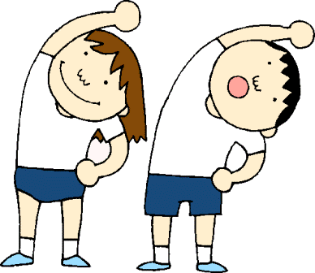

**Homework** *Gwaith Cartref*

**Home Reading Books** – Taken home on Mondays to be returned on Fridays. This will include a book for you to read to your child and a book for them to read to you.

**Spellings** –Words go home Monday & tests are Fridays.

**How you can help your child at home?**

Reading – listening to them read.

Encouraging them to learn spellings.

Play maths games on [www.activelearnprimary.co.uk](http://www.activelearnprimary.co.uk)

<https://www.topmarks.co.uk/>

Play phonic games on

<https://www.phonicsplay.co.uk/>

Researching topics / themes.

**Website-** www.greenwayprimary.com

Check the Year 2 class pages on the website to find out what we are learning and see photos of the children’s activities

**School starts at 8.55am and finishes at 3pm.**

**Remember to be in school every day.**

**WATER BOTTLES**: Children can bring a water bottle to

school which we will label. **Water only, please!**

Bottles can be bought from the office for £1.50.

**SNACK**: Children have fruit for their mid-morning snack,

at **£1.50 per week/30p per day** – please pay Mrs Desmond at the start of any day. Alternatively, children can bring in their own fruit

from home. They also have free milk in the afternoon

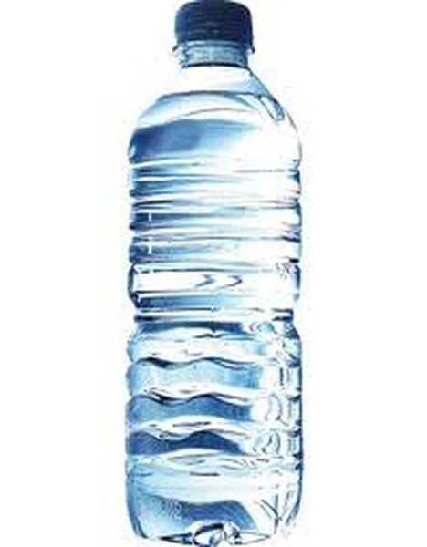  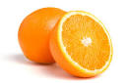 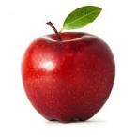 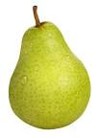

We look forward to another successful term in Year 2

Miss Morgan, Mrs Desmond and Ms Fitzgerald